**Online food ordering system**

**BACHELOR OF TECHNOLOGY in**

**COMPUTER SCIENCE AND ENGINEERING**

Submitted By

**Reg No Name Roll No**

12213327 Venkata Naidu RK22RZA19

12212594 Prachi RK22RZB38

12209344 Alok Pandey RK22RZB66

Under the guidance of

# Dr.Mohammad Faiz



**School of Computer Science and Engineering**

Lovely Professional University

Phagwara, Punjab (India)

**ACKNOWLEDGMENT**

Place: Lovely Professional University

Date: 1st December 2022

# I would like to thank ‘Dr.Mohammad Faiz for assigning us with this project. Through the project I am able to grasp more technical and have a hands-on practical experience with projects. Through it I am able to learn how a project is created and how necessary and crucial technical knowledge is. I am really grateful to the faculty that has provided me with the necessary guidelines

.

**Reg No Name Roll No**

12213327 Venkata Naidu RK22RZA19

12212594 Prachi RK22RZB38

12209344 Alok Pandey RK22RZB66

**DECLARATION STATEMENT**

Place: Lovely Professional University

Date:1st December, 2022

This is to declare that this report has been written by me. No part of the report is copied from the other sources. All information included from other sources has been duly acknowledged.

**Reg No Name Roll No**

12213327 Venkata Naidu RK22RZA19

12212594 Prachi RK22RZB38

12209344 Alok Pandey RK22RZB66

# TABLE OF CONTENTS

***CONTENTS PAGE NO.***

1. **INTRODUCTION ..................................................................................... 1**
2. **ACKNOWLEDGEMENT ........................................................................ 2**
3. **DECLARATION ...................................................................................... 3**
4. **ABSTRACT ............................................................................................... 5**
5. **ENTITY RELATION DIAGRAM………………………………………7**
6. **LIST OF ENTITIES AND ATTRIBUTES…………………………….. 8**
7. **MAPPING TO ER DIAGRAMS…………………….………………….10**
8. **SQL CODES……………………………………………………………...12**

**ABSTRACT**

The purpose of Online Food Ordering System is to automate the existing manual system by the help of computerized equipment and full-fledged computer software, fulfilling their requirements, so that their valuable data/information can be stored for a longer period with easy accessing and manipulation of the same. The required software and hardware are easily available and easy to work with.

This paper presents an online food ordering system for a restaurant website. The system provides customers with an easy and convenient way to order food online. The goal of the system is to automate the ordering process, enabling customers to place their orders quickly and easily. The system is designed to be user-friendly, allowing customers to select their preferred meal, specify the desired quantity, and pay for the order. The system also includes an administrative panel, enabling the restaurant to monitor and manage orders. Finally, the system is designed to be secure, protecting customers’ personal and payment information. The system is implemented using HTML, CSS and JavaScript, and tested on a local server. The results show that the system is easy to use and meets the customer’s needs.

Online Food Ordering System, as described above, can lead to error free, secure, reliable and fast management system. It can assist the user to concentrate on their other activities rather to concentrate on the record keeping. Thus it will help organization in better utilization of resources. The organization can maintain computerized records without redundant entries. That means that one need not be distracted by information that is not relevant, while being able to reach the information.

The aim is to automate its existing manual system by the help of computerized equipments and full-fledged computer software, fulfilling their requirements, so that their valuable data/information can be stored for a longer period with easy accessing and manipulation of the same. Basically the project describes how to manage for good performance and better services for the clients.

**Introduction**

The "Online Food Ordering System" has been developed to override the problems prevailing in the practicing manual system. This software is supported to eliminate and, in some cases, reduce the hardships faced by this existing system. Moreover, this system is designed for the particular need of the company to carry out operations in a smooth and effective manner.

The application is reduced as much as possible to avoid errors while entering the data. It also provides error message while entering invalid data. No formal knowledge is needed for the user to use this system. Thus, by this all it proves it is user-friendly. Online Food Ordering System, as described above, can lead to error free, secure, reliable and fast management system. It can assist the user to concentrate on their other activities rather to concentrate on the record keeping. Thus, it will help organization in better utilization of resources.

Every organization, whether big or small, has challenges to overcome and managing the information of Category, Food Item, Order, Payment, Confirm Order. Every Online Food Ordering System has different Food Item needs; therefore, we design exclusive employee management systems that are adapted to your managerial requirements. This is designed to assist in strategic planning and will help you ensure that your organization is equipped with the right level of information and details for your future goals. Also, for those busy executives who are always on the go, our systems come with remote access features, which will allow you to manage your workforce anytime, atall times. These systems will ultimately allow you to better manage resources

My motivation for creating this app stemmed from the fact that my family works in the fast food industry, and I dislike waiting in lines or having to call ahead to place an order, especially during peak lunch or dinner hours. In addition, I value my current knowledge of the Java and JSP programming languages, as well as understanding how strong and dynamic they are when it comes to web design and application development. Because I found them to be highly beneficial when working on the technologies, I used JavaScript, JSP, HTML, and Java to develop this application on the client side, and Oracle database on the back end.

**ENTITY RELATION DIAGRAM**

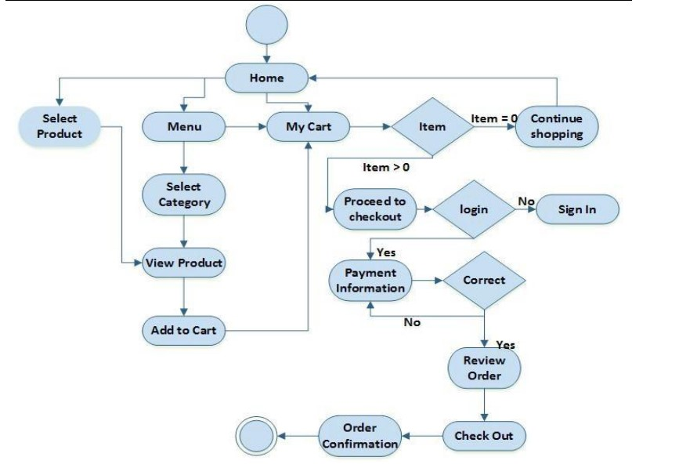

**LIST OF ENTITIES AND**

# ATTRIBUTES

|  |  |
| --- | --- |
| ENTITIES | ATTRIBUTES |
| Breakfast | Poha  Samosa  Fried rice  Paratha  Jalebi  Coffee  Tea  Idli  Dosa |
| Lunch | **Veg Non-veg**  Roti Chicken Biryani  Sabji Hyderabadi Biryani  dal kabab  Fried Rice Chicken Fried rice  Paneer Tandoori Chicken  Papad Fish  Curd Mutton curry  Salad Egg Fried Rice  Sambar Rice Egg Burji |
| Dinner | Dosa  Chole Bhature  Chole Khulche  Momos  Uggani  Chowmin  Manchurian  Raita  Khoptha |
| Login/signup | User_id  Password  New User? Then Sign Up  Email  Number |
| About us | Free delivery  Easy Payments  Availability 24/7 |

|  |  |
| --- | --- |
| Home (UI) | Home  Menu  About  Review  Contact  Orde |

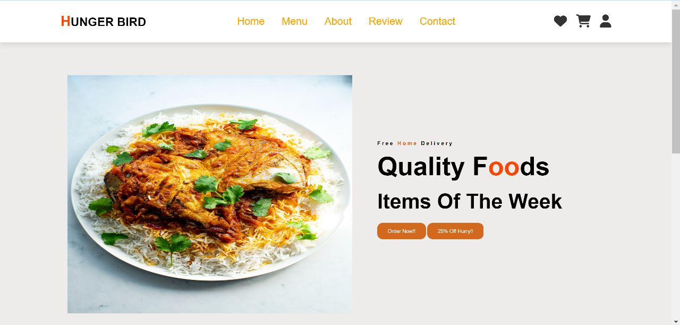

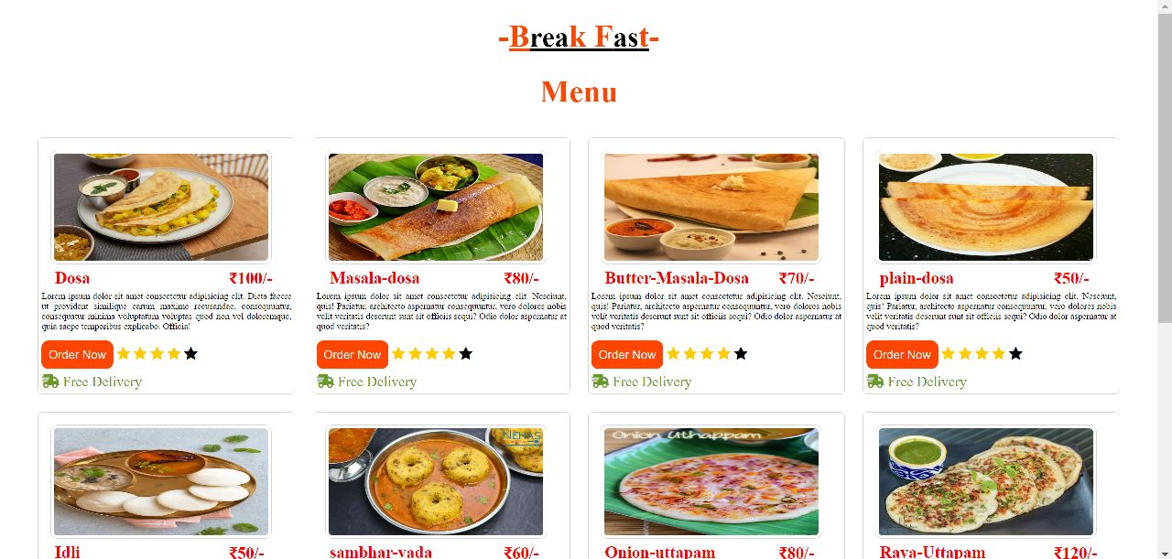

**Conclusion of the Project Online Food Ordering System:**

Our project is only a humble venture to satisfy the needs to manage their project work. Several user friendly coding have also adopted. This package shall prove to be a package in satisfying all the requirements of the school. The objective of software planning is to provide a frame work that enables the manger to make reasonable estimates made within a limited time frame at the beginning of the software project and should be updated regularly as the project progresses.

At the end it is concluded that we have made effort on following points...

• A description of the background and context of the project and its relation to work already done in the area.

Made statement of the aims and objectives of the project.

The description of Purpose, Scope, and applicability.

We define the problem on which we are working in the project.

We describe the requirement Specifications of the system and the actions that

Finally, for the online meal ordering system, we created a secure, user-friendly food ordering administration system. Whether they are Administrators or Customers, this system can look after them all. This system will let them manage client meals, delivery boy data, and expand without creating any disruption. This system is completely secure because each user is assigned a unique user ID and password, preventing unauthorised access. With online payment, registration, and cancellation, it's a lot easier to use. As a result, using this strategy will help to minimise labour expenses while also giving clients more opportunity to enjoy the services.

**Future work:-**

The work that will be implemented with future editions of the software is described in the following section.

* Allow customers to modify orders: Allow clients to customise their food orders.
* Improve the user interface by include more interactive features for the user. Add information about deals and promotional offers on the home page. Add a week/worth day's of recipes to the home page.
* Payment Options: PayPal, cash, and gift cards are just a few of the options available. Allows you to save payment details for future use.\
* Delivery Options: Include a delivery choice.
* Order Process Estimate: Show the customer a graphical order status gauge.
* Order Status: Only active orders will be shown to restaurant employees.
* Order Ready notification: Send an Order Ready notification to the customer.

**REFERENCES**

* Google for problem solving
* http://www.javaworld.com/javaworld/jw-01-1998/jw-01-Credentialreview.html
* 0 Database Programming with JDBC and Java by O'Reilly
* Head First Java 2nd Edition
* . http://www.jdbc-tutorial.com/
* Java and Software Design Concepts by Apress
* . https://www.tutorialspoint.com/java/
* http://www.javatpoint.com/java-tutorial
* 0 https://docs.oracle.com/javase/tutorial/
* http://www.wampserver.com/en/
* http://www.JSP.net/
* http://www.tutorialspoint.com/mysql/
* httpd.apache.org/docs/2.0/misc/tutorials.html